**Title of the project**: Online Pharmacy

# Group name: - GROUP - C



***Created by: -***

**SUBHAJIT**

**B**

**ANERJEE**

**&**

**SWAPNENDU LET**

# Contents

1. Introduction and objective of the project
2. Problem Definition
3. Tools/Platform, Hardware and software

Requirement Specification.

1. Analysis of the project (project planning DFD,

ERD)

1. Security of the project
2. Future scope and further enhancement of the project
3. Bibliography

## Introduction and objective of the project: -

Online Pharmacy (E- Pharmacy) is an interactive e-commerce solution providing users with an opportunity to buy and sell medicines. We provide a constructive service to each and every person to furnish their needs in terms of medicines, consultations and Queries by providing them with an online platform where they can buy medicines for affordable price. This website provides users with wide range of medicines and surgical items which gets a check based on their condition and fixed to its best and delivered to customer’s doorsteps.

## Problem definition: -

Medicines have become a daily need of most of the people these days. Now most of the difficulty is faced by old aged people. Doctors prescribe few medicines which are not always available so they need to run from one shop to another to buy medicines. So, through this online pharmacy they can buy(order) medicines from the comfort of their home. After successful order their medicines will be delivered at their doorstep and also, they can get discount.

**Tools/Platform, Hardware and Software Requirement specifications:**

**Software Requirements:**

|  |  |
| --- | --- |
| **Name of component** | **Specification** |
| **Operating System**    **IDE** | Windows 98 , Windows XP , Windows7,  Linux, Windows 10, Windows 11 eclipse |
| **Language** | Java 2Runtime Environment,  CSS, html, JavaScript, MySQL |
| **Database** | MySQL Server |
| **Browser** | Any of Mozilla, Opera, Chrome, Microsoft  Edge etc |
| **Web Server** | Tomcat 7 or above (recommended 9) |
| **Software Development Kit** | Java JDK 1.7 or above |
| **Scripting Language Enable** | JSP (Java Server Pages) |
| **Database JDBC Driver** | MySQL Jar connector |
| **Hardware Requirements:** |  |
| **Name of component** | **Specification** |
| **Processor** | Pentium III 630MHz |
| **RAM** | 128 MB |
| **Hard disk** | 20 GB |
| **Monitor** | 15” color monitor |
| **Keyboard** 122 keys | |

**Software Requirement Specification**

The Software Requirements Specification is produced at the culmination of the analysis task. The function and performance allocated to software as part of system engineering are refined by establishing a complete information description, a detailed functional and behavioural description, an indication of performance requirements and design constraints, appropriate validation criteria, and other data pertinent to requirements.

**The proposed system has the following requirements:**

* System needs store information about new entry of User.
* System needs to maintain Medicine quantity record.
* System needs to keep the record of sales.
* System needs to update and delete the record.
* System also needs a search area.

It also needs a security system to prevent data leakage.

## Analysis of the project (Project Planning DFD, ERD): -

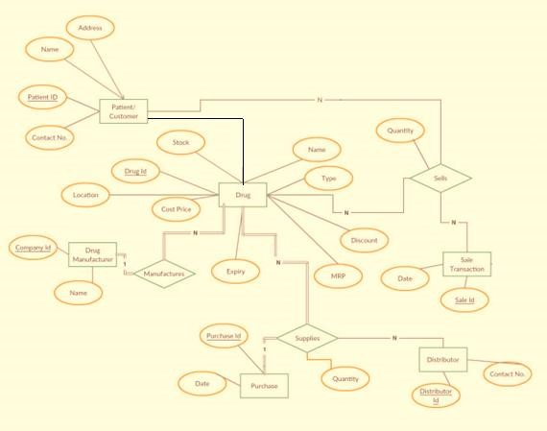

ENTITY RELATIONSHIP DIAGRAM (ERD)

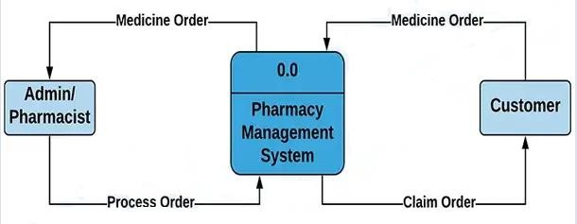

CONTEXT LEVEL DFD

LEVEL

-

1

DFD

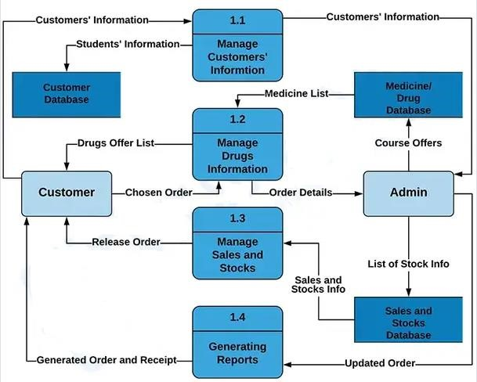

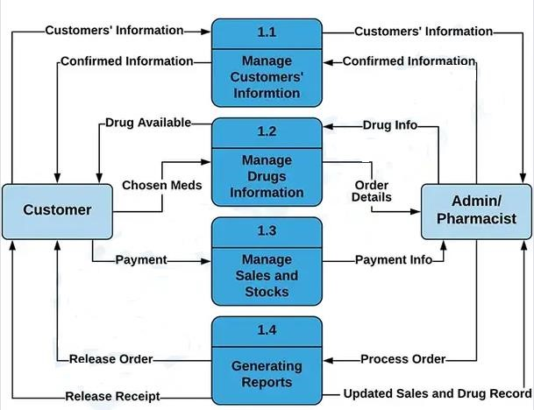

LEVEL

–

2

DFD

## Security of the project: -

Access to all areas of the system is protected by the sign in code of the user.

* Passwords can be enabled in all areas of the system. • Based on the security level of the user, areas are protected by higher levels of security.
* Software is available 24 X 7
* Multiple Firewall Protection - The hosting centre is protected by multiple firewalls.
* Offsite Data Storage - As well as daily backup of the systems, data is also stored off site to ensure any failures are fully recoverable.

## Future Scope and further enhancement of the project: -

* This would help each and every person to find any medicine via our website and get it at home it will save their time.
* It would provide vast medicines of all fields.
* People will get consultation services from a doctor.
* We can connect it to a web server and can make it live for everyone.
* We can also design an app for users for better customer service.
* To create a backup mechanism for backing up data and information.

## Bibliography: -

1. Guide: - Mr. Gurudev Adhikary
2. Mentor: - Mr. Rahul Sharma
3. YouTube tutorial: - Code with Harry
4. [www.google.co.in](http://www.google.co.in/)
5. www.wikipedia.com